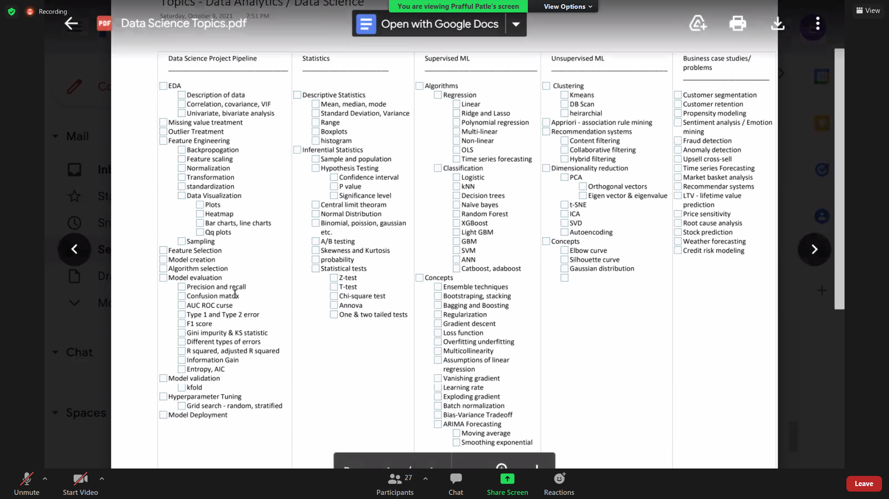

Pdfdrive.com for data science interview questions and answers.

https://www.pdfdrive.com/

Asif-bhat in linkedin

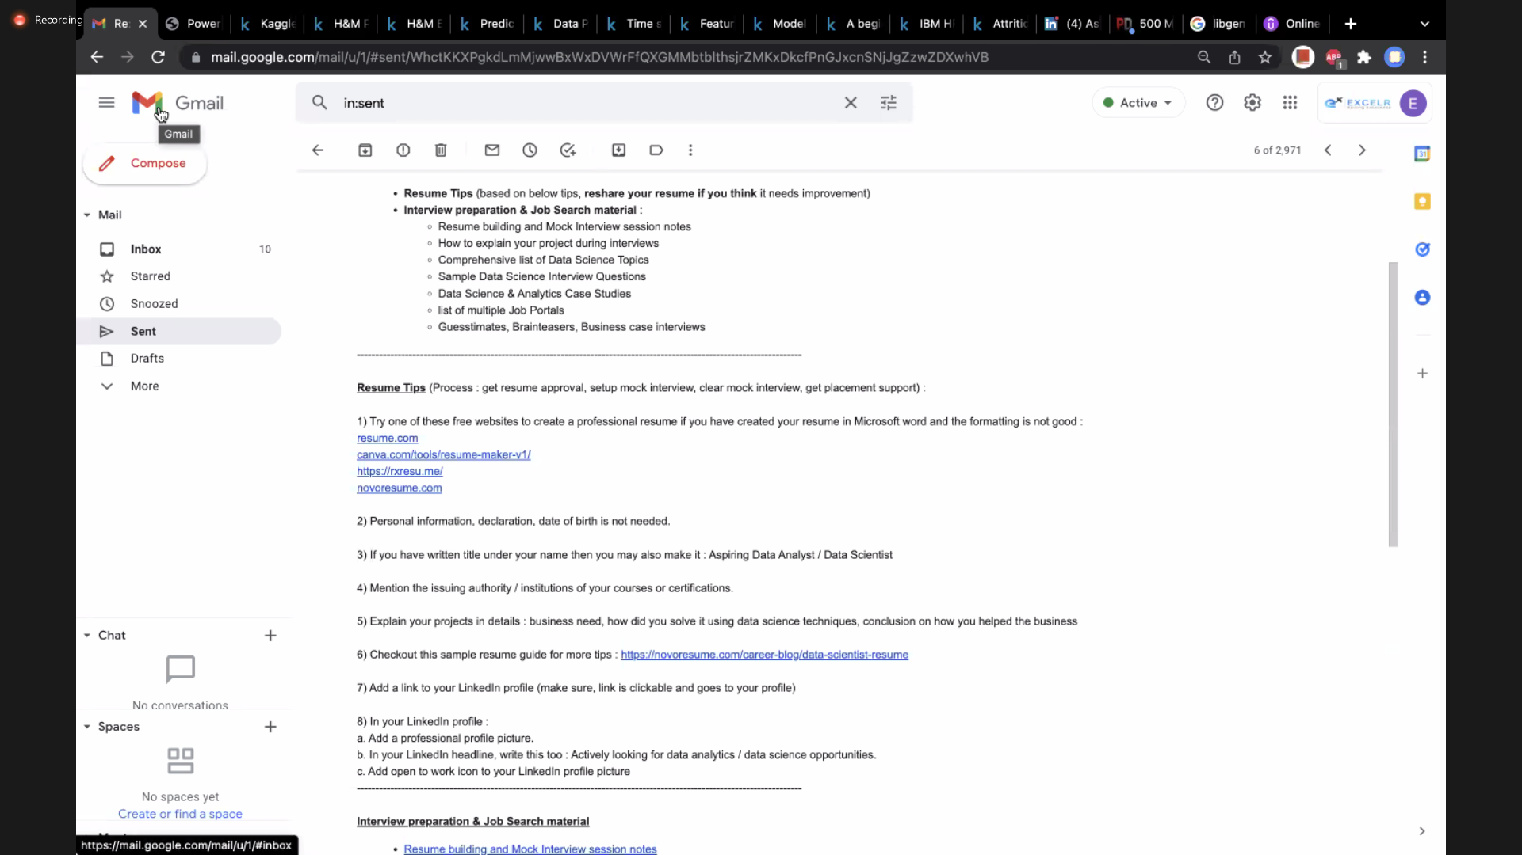

[interviewmonitor@excelr.com](mailto:interviewmonitor@excelr.com)

